St Joseph's Attendance Newsletter
November 2017
Welcome to the Autumn 2 ‘Attendance Newsletter’ for 2017/2018!
Attendance will be a focus for St Joseph’s School this year to ensure we have a good level of attendance across school.
End of Autumn 1 Term 2013 | End of Autumn 1 Term 2014 | End of Autumn 1 Term 2015 | End of Autumn 1 Term 2016 | End of Autumn 1 2017
96.5% | 96.3% | 95.8% | 95.5% | 96.1%

Doncaster Council deems satisfactory attendance as 96% or above.
Our target for 2017/2018 is 97%. We are currently below this target.
Class (Aut 1 2016) | Authorised Absences | Unauthorised Absences | % Attend
Reception | 2.7% | 1.3% | 95.9%
Class 1 | 1% | 1.2% | 97.8%
Class 2 | 1.6% | 3.7% | 94.7%
Class 3 | 1.9% | 2.1% | 96.1%
Class 4 | 2.3% | 2.4% | 95.3%
Class 5 | 1.8% | 1.2% | 97%
Class 6 | 2.6% | 1.6% | 95.7%
Totals | 1.9% | 2.0% | 96.1%

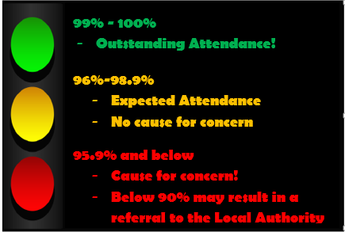
Term Time Holidays
Please note: Term Time holidays can only be authorised in exceptional circumstances.
All term time holidays which are unauthorised can result in a fine.
We will be contacting you during the Autumn 2 half term if your child’s attendance drops below 95% or if punctuality is a concern.
At the parents evening in January, all parents you will receive details informing you of your child’s attendance and punctuality information.

Class in 2016 | Number of Children achieving 100% in Autumn 1 half term 2016 | Number of Children achieving 100% in Autumn 1 half term 2017
Reception |  | 14
1 | 16 | 14
2 | 16 | 14
3 | 16 | 15
4 | 16 | 12
5 | 21 | 14
6 | 18 | 11
(Y7) | 14
Total | 117 | 94
100% Attendance – Autumn 1 2016 and Autumn 1 2017
Well done to the 94 children across school who have had 100% attendance for the whole year so far! Keep it up. Just like last year, there will be special prizes and awards for anyone who has 100% attendance for the full year.
Don’t forget Early Bird Week –
Week Beginning
27th November!

Did you know…

Key Stage 2 data shows a very clear link between attendance and attainment. Although we don’t use levels anymore, the findings are still very relevant. The table below shows the average attendance and number of days in school for children in year 6. Those children who achieved level 4+ (the expected standard) in reading, writing and maths, or made expected progress spent on average at least 4 more days in schools than those who failed to achieve those measures!
 | % attendance of those who did not achieve | Average days attended of those who did not achieve | % attendance of those who did achieve | Average days attended of those who did achieve
Reading, Writing & Maths Level 4 | 94.6 | 179 | 96.9 | 184
Expected progress in Reading | 94.8 | 180 | 96.5 | 183
Expected progress in writing | 93.6 | 177 | 96.5 | 183
Expected progress in maths | 94.4 | 179 | 96.6 | 183
4 days does not seem like a lot of time, but this data shows the impact.
Remember – every day counts!

